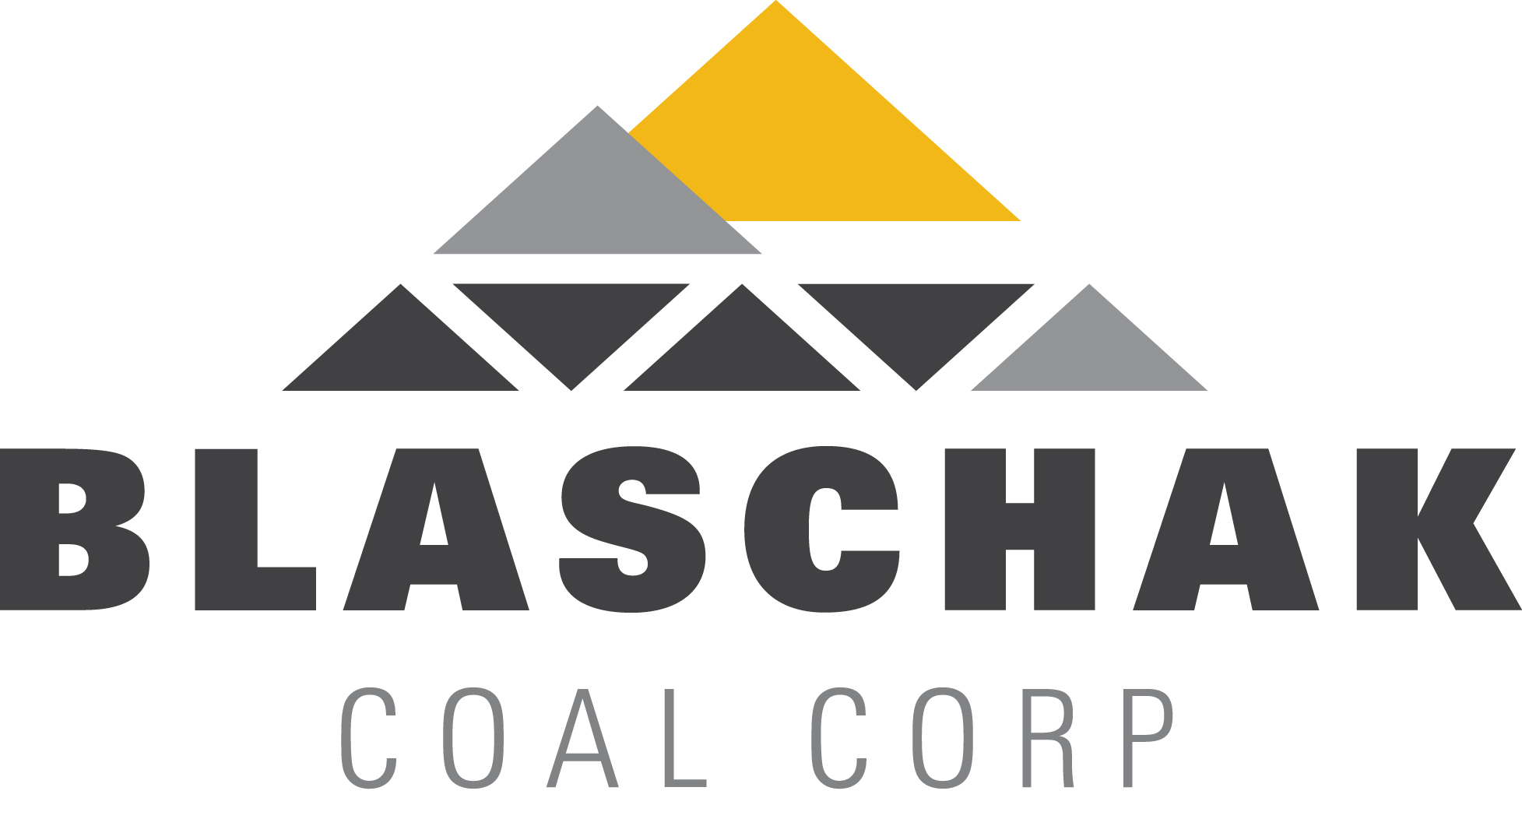

**FOR IMMEDIATE RELEASE**

**Media Contact:**

Emily Geesaman

[geesaman@buchananpr.com](mailto:geesaman@buchananpr.com)

(610) 649-9292

**Blaschak Coal Corp. Sets Production Record in 2012**

*Back-to-Back Years of Growth Continue with Increased Investment from*

*Majority Owner Milestone Partners*

**MAHANOY CITY, PA—September 26, 2012—**[Blaschak Coal Corp.](http://www.blaschakcoal.com/) today announced the company has reached another record in coal mine production, surpassing last year’s record in less than nine months.

This is the second year in a row that Blaschak has experienced record-setting production levels. In 2011, the 75-year-old coal company’s “run of mine” coal production exceeded 642,000 tons. Through the third quarter of 2012, Blaschak’s run of mine coal production has surpassed 680,000 tons. The company expects that level to increase beyond 800,000 tons by the end of 2012.

Blaschak’s success has been due, in large part, to the continued capital investment from Blaschak’s shareholders, including [Milestone Partners](http://www.milestonepartners.com/), as well as the support of its lenders. The strategic acquisition of a new mine site and associated processing plant in Lattimer, Pa., as well as continued investment in excavating and processing equipment in 2011 and 2012 has enabled Blaschak to increase its production capacity, resulting in growth of the company for the second straight year in a row.

“We’re already starting to see a return on the additional investments we’ve made into expanding Blaschak’s operations over the past two years. With additional production, the company has been able to enter new markets and grow sales,” said John Nowaczyk, principal at Milestone Partners. “This is an exciting time for Blaschak and we’re eager to continue to finance the growth into the future.”

Blaschak’s business model, which successfully integrates production, processing and distribution, helps to strengthen the company’s leading position in the marketplace.

“The continued investment from our financial partners has helped fuel Blaschak’s appetite for growth and we don’t plan on slowing down anytime soon,” said Greg Driscoll, chairman and CEO of Blaschak. “Our record level production is part of the company’s preparation for long-term increased demand for [anthracite](http://www.blaschakcoal.com/).”

Based in the heart of coal country in Northeastern Pennsylvania, Blaschak sits atop the largest known anthracite field in North America. According to the [Pennsylvania Anthracite Council](http://paanthracite.com/index.html), there are 4 to 6 billion tons of reserves of anthracite left in the Northeastern Pennsylvania region.

Blaschak’s increase in production resulted in more than 40 new jobs being added over the last two years. Blaschak now employs approximately 150, with further growth anticipated in 2013.

**About Blaschak Coal Corp.**

**Blaschak Coal Corp.** (www.blaschakcoal.com) is a miner, preparer and marketer of Pennsylvania anthracite. Blaschak is a market leader and one of the few fully integrated U.S. anthracite companies with a large reserve base, multiple mines, multiple preparation plants, a bagging plant, both rail and truck loading facilities and extensive marketing operations serving a wide range of end markets, including home heating, steel and water filtration.

*# # #*